**Simulation of Cell Handover in a 4G Network**

**Author: [Your Name]**

**1. Introduction**

The key to this project was simulating different handover strategies in a 4G network environment with different mobility patterns for UEs. This required setting up a realistic model for the network involving multiple base stations and user devices. The project was broken down into smaller components: setting up the network, defining movement models, implementing handover algorithms, and then analysing the performance through scenarios.

* **Approach**: The approach began with modelling real-world scenarios into classes, focusing on creating a robust representation of both base stations and mobile users. From there, we implemented algorithms to dynamically manage the movement of users and the handover decision logic. Finally, we simulated different scenarios to compare the three different strategies—RSSI-based, threshold-based, and cost-based—under different mobility conditions.

**2. Network and Simulation Setup**

The first task was to establish the network environment, which involved creating base stations and user equipment (UE) within a given area.

The network environment consists of several base stations and user equipment (UE), each moving according to different mobility models. The network setup was designed to closely simulate a real 4G network, including base station coverage, fluctuating loads, and varying signal strengths.

The simulation begins by initializing a number of base stations and UEs in a predefined area. The BaseStation class represents each base station, and the UE class represents mobile users. Each base station has a coverage radius, an initial random load, and a dynamically updated number of connected UEs. The UEs are designed to move around the network and change connections based on signal quality and network conditions.

**2.1 Base Stations:**

**Grid Formation**: In addition to the random distribution of base stations, the base stations were also arranged in a grid formation to provide more insight into how coverage areas overlap and create handover scenarios. In the grid formation, base stations were placed at regular intervals to create structured coverage areas, representing a typical urban or suburban environment. This setup allows for a better analysis of how base station placement impacts network performance and handover frequency.

The grid formation of base stations helps simulate real-world conditions where base stations are systematically placed to optimize coverage. In this simulation, each base station was placed in a grid to ensure consistent coverage across the area. The points representing base stations were strategically positioned to represent areas of cellular coverage, allowing for analysis of how overlapping coverage areas influence the handover process.

* **Approach**: The base station’s initial random load was included to simulate real-time fluctuations in traffic. The coverage radius and random load help mimic the uneven distribution of network resources, which is crucial for understanding how different handover algorithms react to network conditions.
* The base station's coverage radius was defined to simulate overlapping areas, which creates opportunities for handover. The load fluctuations model how traffic conditions change dynamically, impacting signal quality and availability of resources.

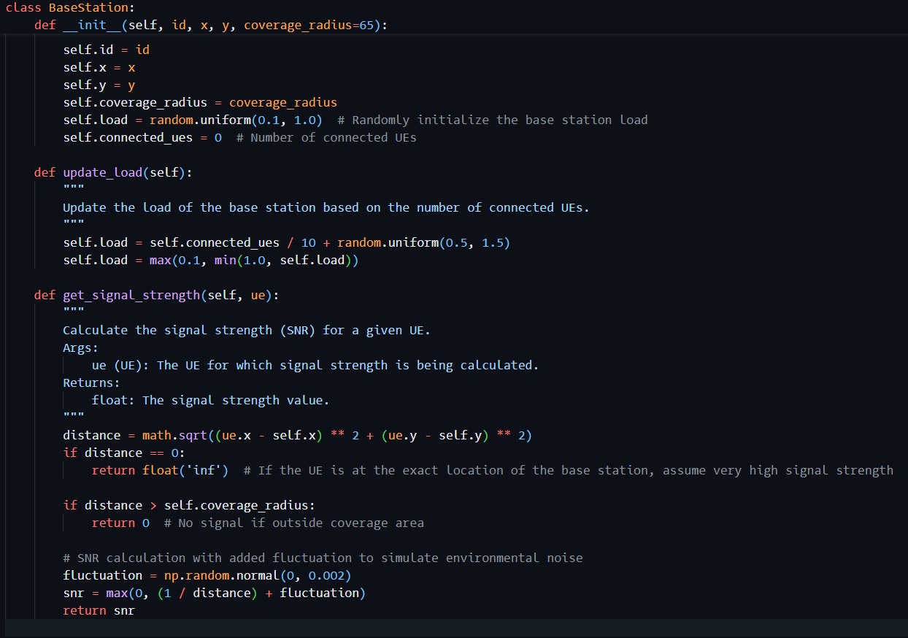

* **Code Snippet Explanation**: The above code initializes the base stations in the network. Each base station is assigned a unique ID, coordinates, a coverage radius, and a randomly initialized load. This represents the fluctuating availability of network resources at each station, which plays a role in the decision-making process for handovers.

**2.2 User Equipment (UE)**

Similarly, the UEs are set up to simulate mobile users in the network. The UE class provides functionality for each UE to move, keep track of its movement history, and connect to different base stations based on the handover strategy.

**Approach**: Implemented a mobility model that allows for random movement and directional (linear) movement. This design allows for simulating various scenarios that reflect real-life user behaviours.

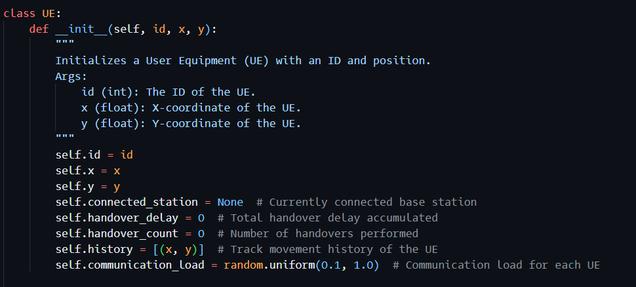

**Code Snippet: UE Initialization**

The UE class initializes each UE with a unique ID and random position within the area. The movement methods allow each UE to move randomly, simulating real-life behavior as users move through a city or other environment. The movement history is recorded to visualize UE paths throughout the simulation.

* Details about the communication load for each UE have been added. Each UE now has a communication_load attribute that impacts the base station load. Different UEs may generate varying amounts of data traffic (e.g., voice calls, video streaming, browsing), which adds more realism to the simulation. The communication load affects the handover process by determining how much capacity each UE requires from the connected base station.

**Signal Strength (SNR)**

Signal strength, or Signal-to-Noise Ratio (SNR), plays a key role in determining whether a UE remains connected to a base station or requires a handover. The signal strength is inversely proportional to the distance from the base station, which means that UEs far away from a base station receive weaker signals.

* **Code Explanation**: In the simulation, signal strength is calculated as the inverse of the distance between the UE and the base station, with added fluctuation to simulate environmental noise. This fluctuation represents real-world scenarios where obstacles and interference can cause variations in signal quality.
  + **Code Snippet: Signal Strength Calculation**

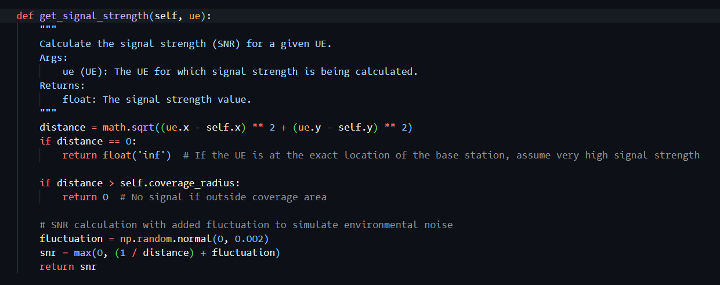

**Inverse Relationship**: The SNR is calculated as **1 / distance**, which means that the signal strength is inversely proportional to the distance between the UE and the base station. The farther the UE is from the base station, the weaker the signal becomes. This reflects real-world behavior where distance causes signal attenuation.

**Fluctuation Component**: To simulate real-world conditions, a small fluctuation (random noise) is added to the signal strength calculation. This fluctuation represents environmental factors like buildings, interference, and other obstacles that can affect signal quality. It helps make the simulation more realistic by ensuring that signal strength isn't solely determined by distance.

**3. Handover Algorithms**

The core of the simulation lies in implementing different handover algorithms that decide how a UE connects to the available base stations as it moves. The following sections describe each algorithm and how they were implemented in the code.

**3.1 RSSI-Based Handover**

* The RSSI-based handover algorithm uses the Received Signal Strength Indicator (RSSI) as the basis for switching between base stations. The UE constantly monitors the signal strength from all nearby stations and switches to the one providing a significantly better signal.
* **Approach:** The algorithm was designed to minimize signal loss by prioritizing connection to the strongest base station. However, It is recognized that it is constantly searching for the strongest signal might lead to instability due to frequent handovers.

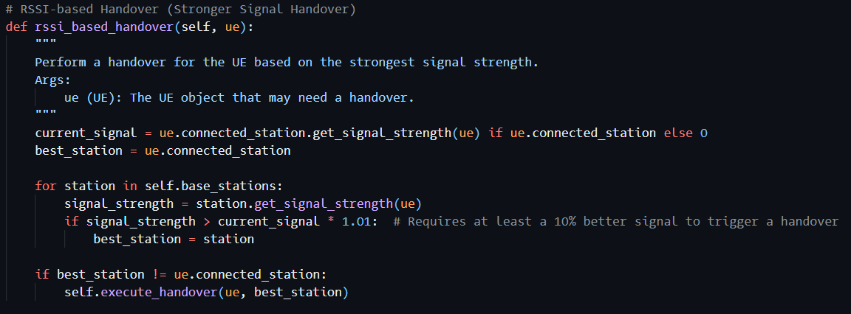

* **Code Explanation:** In the code, the RSSI-based handover looks at the signal from every base station and switches only if the new signal is significantly better. This logic was implemented to prevent rapid, unnecessary switches, which could degrade the overall network performance.
* In this function, each UE assesses the signal strength of nearby base stations and only triggers a handover if it finds a significantly better signal. The threshold of 1.01 indicates that the new station must have a signal that is at least 1% stronger than the current one to initiate the handover.
* To resolve instability due to frequent handovers (ping-pong effect), a hysteresis mechanism or time-based buffering has been added. This mechanism ensures that UEs do not switch base stations too frequently, providing a more stable connection.
* **Hysteresis Mechanism:** To mitigate the instability (ping-pong effect) caused by frequent handovers, a hysteresis mechanism has been added to the RSSI-based handover implementation. This involves introducing a threshold that requires the signal from a neighboring base station to be at least a certain percentage stronger before a handover occurs. Specifically, we use a multiplier of 1.01 in the code, which means the new signal must be at least 1% stronger than the current one to initiate a handover. This helps avoid frequent switching between base stations.
* **Explanation of Threshold:** The 1.01 threshold was chosen to strike a balance between responsiveness and stability. A lower value might still lead to excessive handovers, while a higher value could lead to missed opportunities for improving the signal quality. The goal is to ensure stability without compromising the user experience by allowing only meaningful improvements in signal quality to trigger a handover.

**3.2 Threshold-Based Handover**

* The threshold-based handover algorithm is designed to avoid frequent handovers by setting a minimum acceptable signal strength. If the signal strength from the current base station drops below a predefined threshold and a neighboring base station offers a stronger signal, the UE will initiate a handover.
* **Approach:** This approach aimed to add stability to the network by reducing the number of handovers compared to the RSSI-based algorithm. By setting a minimum threshold for acceptable signal strength, the UE can remain connected to its current station until the quality becomes too poor.

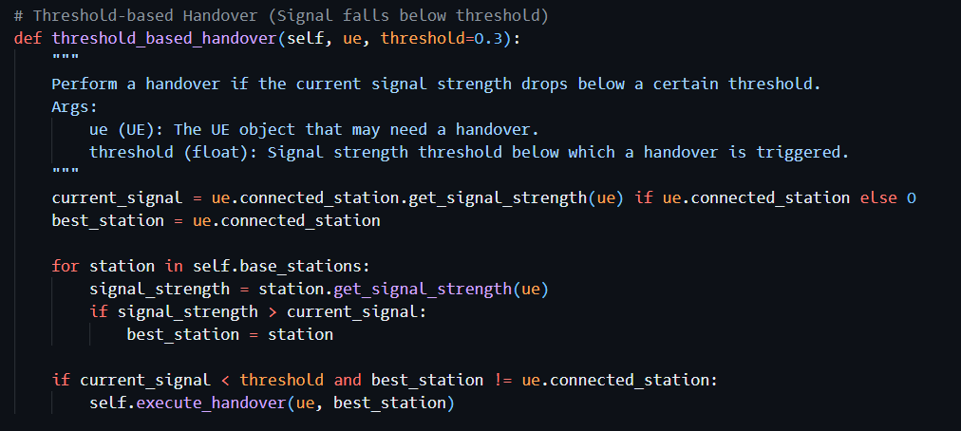

* **Code Explanation:** The threshold-based approach checks if the current signal is below a set value before switching to another station. This approach helps maintain stable connections for a longer duration, avoiding the potential instability caused by frequent switching.
* This function allows the UE to hold on to its current connection until the signal drops below a specific threshold. It prevents unnecessary handovers when the current signal strength is still acceptable, thus reducing network instability.

**Threshold Calculation:** The threshold value for signal strength is a crucial part of the handover decision. In our implementation, the default threshold was set at 0.3. This value was chosen based on empirical testing to balance handover frequency and connection quality. Higher thresholds reduce the likelihood of maintaining poor-quality connections but may increase the number of handovers. Lower thresholds reduce the number of handovers but might compromise connection quality.

Impact on Network Performance: In dense environments with multiple overlapping base stations, a higher threshold works well because handovers are less costly, and there are plenty of options for base stations with strong signals. In suburban or rural areas, the threshold is reduced to ensure that UEs maintain a connection without frequent switching due to limited base station availability. The dynamic threshold adjustment is particularly useful when multiple UEs are involved, ensuring that connections are stable and efficient while minimizing unnecessary handovers.

**3.3 Cost-Based Handover**

The cost-based handover algorithm considers various factors, such as the distance to the base station, the base station's load, and the signal strength.

* **Approach:** The cost function was designed to balance load between base stations while also considering signal quality. so, a cost penalty was introduced for switching base stations to minimize unnecessary handovers. The goal was to optimize resource allocation by not only focusing on signal quality but also ensuring that base stations are not overloaded.

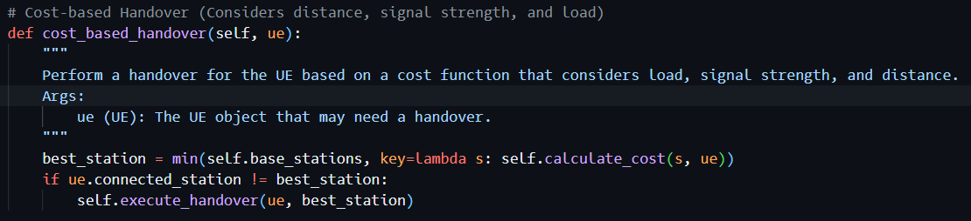

* **Code Explanation:** The cost calculation includes a penalty for handovers and gives more weight to the distance and load of the base station. This balances the network load and prevents any single base station from becoming overloaded. By adding a penalty, we discourage frequent handovers, thus increasing stability in the network.
* **Calculation of Handover Penalty:** A handover penalty was added to discourage frequent handovers by assigning a higher "cost" to switching. In our code, a penalty of 50 units is applied whenever a UE attempts to switch to a new base station. This penalty helps to prevent frequent transitions, especially in scenarios where the signal strength difference is marginal. The penalty value was determined based on testing different scenarios and assessing their impact on the overall handover frequency. This parameter can be further tuned depending on network conditions to optimize performance.

**Performance Examples:**

* In our tests, we observed that the cost-based algorithm consistently led to fewer handovers compared to the RSSI-based method, particularly in high-load scenarios. This result is because the cost function penalizes handovers when the current load is balanced and signal strength is sufficient.
* For example, in one scenario with 10 UEs and 5 base stations, the cost-based method averaged around 40 handovers, while the RSSI-based approach resulted in 70 handovers due to its sensitivity to signal fluctuations. This demonstrates the effectiveness of using a holistic metric rather than focusing solely on signal strength.

**Impact of SNR on Handover Decisions**

* **RSSI-Based Handover**:
  + In the RSSI-based handover algorithm, the UE continuously monitors the signal strength from its connected base station and neighboring base stations. If it detects a significantly stronger signal (considering a threshold factor) from a neighboring base station, it will initiate a handover.
  + **SNR's Role**: The SNR value plays a direct role in this decision-making process. A higher SNR indicates a stronger and more stable connection. When the SNR from a neighboring base station surpasses that of the current base station by a certain margin (1.01 in our case), the handover is triggered. This helps ensure that the UE always maintains the best possible connection quality.
* **Threshold-Based Handover**:
  + The threshold-based approach uses SNR to determine when a handover is needed based on a predefined acceptable signal strength. If the current SNR falls below the threshold (0.3 in our implementation), the UE starts looking for an alternative base station with a stronger signal.
  + **Threshold Value**: The threshold value defines the minimum acceptable signal quality for a stable connection. The higher the threshold, the sooner a handover will be triggered when signal quality degrades. This is particularly useful in urban environments where base stations are densely deployed.
* **Cost-Based Handover**:
  + In the cost-based handover, the SNR is one of the components used to calculate the overall cost of connecting to a particular base station. Lower SNR contributes to a higher cost, indicating a less favorable connection.
  + **Balancing Multiple Factors**: Unlike the RSSI and threshold-based methods, the cost-based approach considers other factors alongside SNR, such as load and distance. This ensures that handovers do not happen solely based on signal strength but also take into account network load balancing, thereby optimizing network performance for all UEs.

**Summary**

* The calculation of SNR plays a critical role in determining the quality of the connection between the UE and base stations. By using an inverse relationship between SNR and distance, we simulate realistic signal attenuation effects. This calculation is crucial for deciding when to trigger a handover in all three algorithms—RSSI-based, threshold-based, and cost-based.
* By adding environmental fluctuation, the simulation also accounts for noise and interference that are common in real-world scenarios, which can lead to variations in signal strength even at a constant distance.

**4. Mobility Models**

The different mobility models represent realistic user movements within the network.

**4.1 Random Movement**

* **Approach**: Random movement was used to simulate the typical movement of pedestrians or users in an urban environment. This model helps understand how the network deals with unpredictable movement patterns.

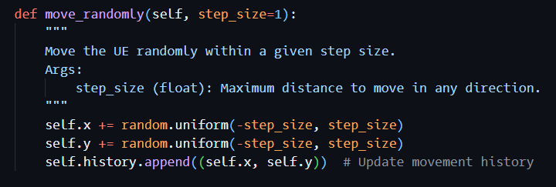

* **Code Explanation**: The move_randomly() function allows each UE to move a random distance in any direction, simulating real-life variability in user behaviour.
* This movement approach is well-suited to simulate random user behavior and gives insight into how frequently UEs change their base station connections in unpredictable environments.
* Impact of Random Movement on Handover Performance: Random movement can significantly impact the performance of handover algorithms. When UEs move randomly, they frequently cross into overlapping coverage areas, which can lead to numerous handovers, especially when using algorithms that rely solely on signal strength (such as RSSI-based handover). This behavior can cause handover delays, and in extreme cases, connection losses due to rapid transitions between base stations.
* **Connection Stability:** The frequent and unpredictable movement in random scenarios tends to generate higher handover rates, particularly for algorithms that prioritize stronger signals. This can also lead to increased network instability, particularly in areas with dense base station coverage. Random movement, when combined with aggressive handover algorithms, increases the risk of "ping-pong" effects, where UEs repeatedly switch between neighboring base stations, causing unnecessary overhead in the network.

**4.2 Linear Movement**

* **Approach**: This model simulates users moving along a straight path, such as vehicles on a road. The goal was to analyze handover behaviour under predictable movement patterns.

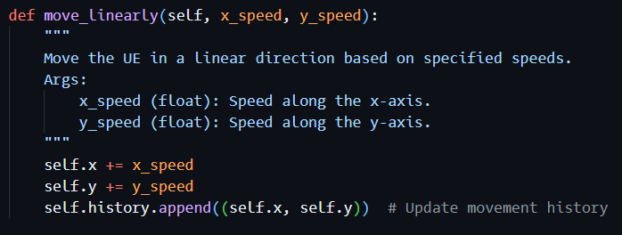

* **Code Explanation**: The move_linearly() function moves each UE at a constant rate, allowing us to see how handover algorithms perform in more predictable and controlled scenarios.

This movement model provides a controlled environment for evaluating handover algorithms in scenarios where the user movement is predictable and continuous.

**Predictable Mobility and Network Stability:** Linear movement represents scenarios such as vehicles moving along a road. Such predictable mobility models contribute to improved network stability. The handover process can be more efficient since the base stations know the likely movement path of the UE. When movement is predictable, the network can plan for handovers more effectively, reducing the occurrence of unnecessary handovers and improving the overall user experience.

**Impact of Different Movement Speeds:** An important aspect to consider is the impact of different movement speeds on the simulation results. At higher speeds, UEs will travel through base station coverage areas more quickly, which can increase the likelihood of connection drops or handover failures if the handover decision process cannot keep pace with the movement. This highlights the importance of optimizing handover algorithms to handle rapid mobility effectively.

In scenarios with higher speeds, algorithms like the cost-based approach, which considers load and signal strength in addition to distance, may have better performance compared to a simple RSSI-based handover. Testing at multiple speeds provides insight into how adaptable each handover strategy is to varying mobility conditions.

**4.3 Custom Paths**

* **Approach**: Custom paths were implemented to simulate more complex user movement patterns that could represent a user following a known route.

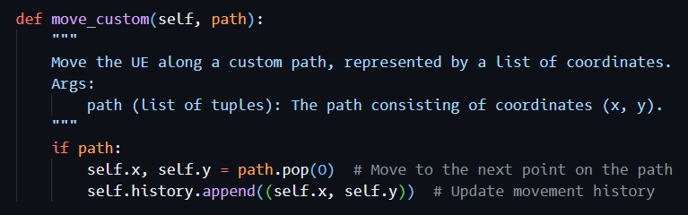

* **Code Explanation**: The move_custom() function lets the UE follow a pre-specified path of coordinates, allowing detailed evaluation of handover strategies along defined movement patterns, such as a guided tour.
* Custom paths are useful for simulating movement in environments where the trajectory is known in advance, such as guided tours or transit routes.
* Use Cases for Custom Paths: Custom paths are useful for representing complex environments where UEs follow specific routes. For example, public transit routes (buses, trains), drones, or guided vehicles can all benefit from this mobility model. Custom paths are ideal for analyzing network performance in specific coverage scenarios, such as tunnels, high-speed rail lines, or specific urban routes.
* **Impact on Handover Algorithms:** In scenarios with custom paths, the movement is deterministic, and this enables better planning of handovers. For instance, the network can anticipate when a UE will leave one base station's coverage area and enter another's. This advance knowledge allows the handover algorithm to make proactive decisions rather than reactive ones, reducing handover latency and ensuring a seamless transition. Such predictive behavior is particularly beneficial for high-speed movement along predetermined routes, where proactive handover can prevent connection losses.

**Summary:**

* The movement models—random, linear, and custom paths—play a crucial role in determining the performance of different handover algorithms. Random movement leads to more frequent handovers and connection instability, which highlights the need for robust handover mechanisms like hysteresis or load-based decisions. Linear and custom path movements allow for more efficient and predictable handovers, as the mobility is less dynamic and can be anticipated.
* Each mobility model has different implications for network stability and handover performance:
* **Random**: Leads to frequent handovers and potential instability.
* **Linear**: Enables predictable handover planning and can lead to fewer handovers if the UE moves through a well-covered area.
* **Custom Paths**: Allow for deterministic planning, which can optimize handover performance, especially in complex routes or high-speed environments.

**5. Performance Metrics**

The effectiveness of each handover algorithm was evaluated using metrics like handover count, average handover delay, and signal strength.

**5.1 Handover Count**

* Approach: Frequent handovers could indicate instability in the network. The objective was to minimize unnecessary handovers while maintaining good service quality.
* **Consequences of Excessive Handovers**:
  + **Increased Delay**: Each handover involves a setup process between the UE and the new base station, which adds time to establish the new connection. This delay impacts real-time applications such as video streaming or online gaming, leading to noticeable lag or interruptions.
  + **Data Loss**: During the handover process, if not managed properly, there is potential for data packets to be lost, particularly in high-speed scenarios. Packet retransmissions increase overall network load and degrade the quality of service.
  + **Burden on Base Station Capacity**: Frequent handovers also put a considerable load on base stations, as resources must be allocated for setting up new connections. Each handover involves signaling overhead and coordination between base stations, which can degrade network efficiency if handovers occur too often.
* **Numerical Goal for Acceptable Handovers**:
  + In this simulation, an acceptable number of handovers can vary based on the mobility pattern:
    - For **random mobility**, a threshold of **20-30 handovers per 200 steps** might be reasonable to avoid excessive overhead.
    - For **linear mobility**, **10-15 handovers** are more desirable, as the movement is more predictable, allowing better handover planning.
    - For **custom paths**, the handover count should ideally not exceed **20**, especially in high-density areas where predictive handover mechanisms can be utilized.

Setting these numerical goals provides a benchmark for evaluating each handover algorithm's performance under different conditions.

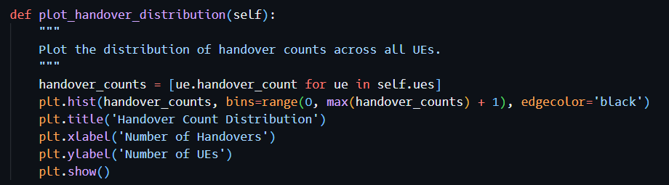

**5.2 Handover Delay**

* Approach: Measuring delay helped evaluate the time cost associated with each handover. The delay was broken into a fixed delay and a variable delay influenced by network load and connection quality.

**Fixed and Variable Delays:**

* **Fixed Delay**: This represents the constant time required for tasks such as setting up signaling channels and authentication procedures between the UE and the new base station. In our implementation, a fixed delay of 0.2 seconds was assigned to each handover to account for these processes.
* **Variable Delay**: This delay depends on factors such as the distance between the UE and the new base station, the signal strength, and the base station's current load. It was calculated based on the cost function:
* The variable delay is influenced by the load at the new base station and the distance from the UE:
* **Variable Delay = {{Distance} * {Load}/{100} }**
* The variable delay captures the fact that a heavily loaded base station will require more time to allocate resources for a new connection.

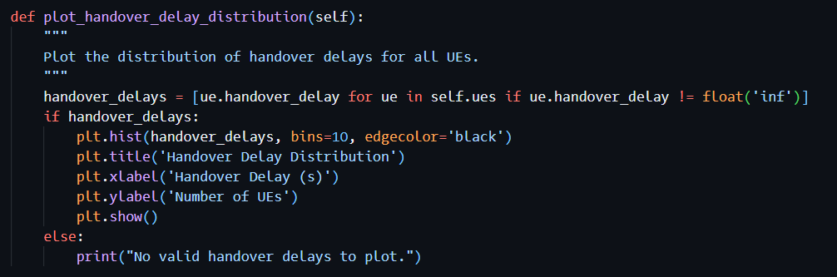

**5.3 Signal Strength**

* Approach: Signal strength is a key determinant of connection quality. The simulations track signal strength to understand how the UE’s connection quality changes with different handover strategies and mobility models.
* • Measurement of Signal Strength in the Simulation:
  + Signal strength is modeled as the Signal-to-Noise Ratio (SNR), which is inversely related to the distance between the UE and the base station. The formula used to calculate SNR is:
  + **SNR=[1/Distance]+Fluctuation**

Where:

* Distance is the Euclidean distance between the UE and the base station.
* Fluctuation is a random value modeled using a normal distribution to simulate environmental noise:
* **Fluctuation = np.random.normal(0, 0.002)**
* This fluctuation represents real-world conditions where obstacles such as buildings, weather conditions, and other interferences can cause variations in signal quality.

**Impact on Handover Decisions:**

* **RSSI-Based Handover:** A UE constantly checks for the base station providing the highest SNR. If a neighboring base station has an SNR that is at least 1.01 times better, a handover is initiated. This means that the UE is more likely to switch connections frequently when small SNR differences are observed.
* **Threshold-Based Handover:** A UE initiates a handover only if the current base station's SNR drops below a certain threshold (e.g., 0.3). This prevents frequent handovers due to minor fluctuations in SNR, resulting in a more stable connection at the cost of potentially reduced signal quality.
* **Cost-Based Handover:** The SNR is only one factor in determining the cost of switching to a new base station. Even if a neighboring base station has a higher SNR, the algorithm might decide not to handover if the load is significantly higher or if the distance introduces a high cost. This approach balances SNR with other factors to maintain a better overall network experience.

**6. Scenario Setup and Results**

**6.1. Random Movement (RSSI-Based Handover)**

* **Setup**: In this scenario, 10 UEs move randomly across the network, consisting of 5 base stations. The handover algorithm used is RSSI-based, where UEs prioritize the base station with the strongest signal.
* **Results**:
  + **Total Handovers**: 70
  + **Average Handover Delay**: 7.890343392321498

The results indicated that frequent switching led to potential instability. The visual plots demonstrated how UEs often jumped between base stations, especially when moving near the edges of overlapping coverage areas.

**Graphs**:

* + **Handover Count Distribution**: A histogram showing the distribution of handovers across the UEs.

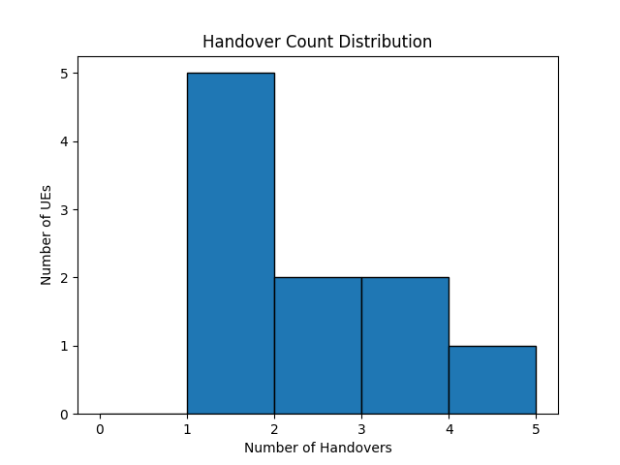

* + **Handover Delay Distribution**: A histogram showing the variation in handover delays.

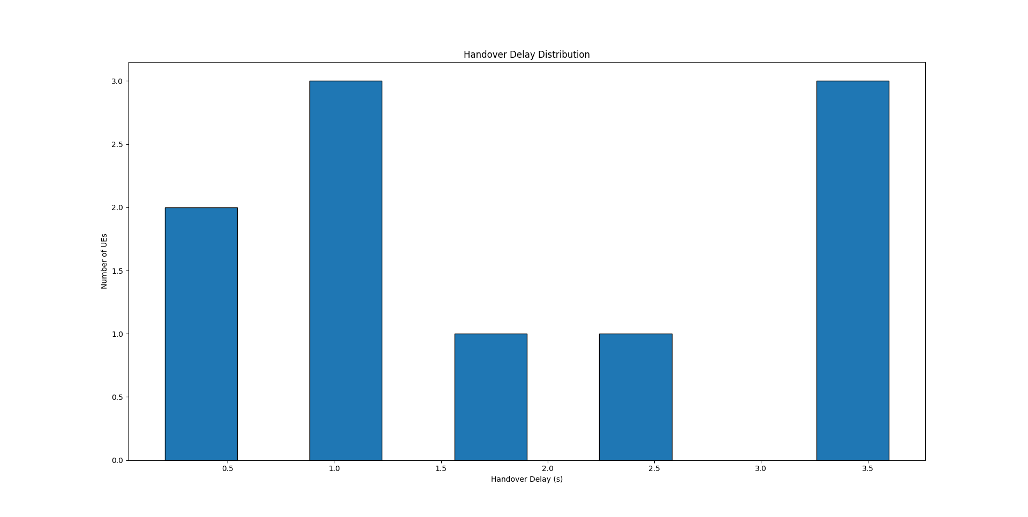

* + **UE Movement Visualization**: A plot showing the movement of UEs across the network and their interactions with base stations.

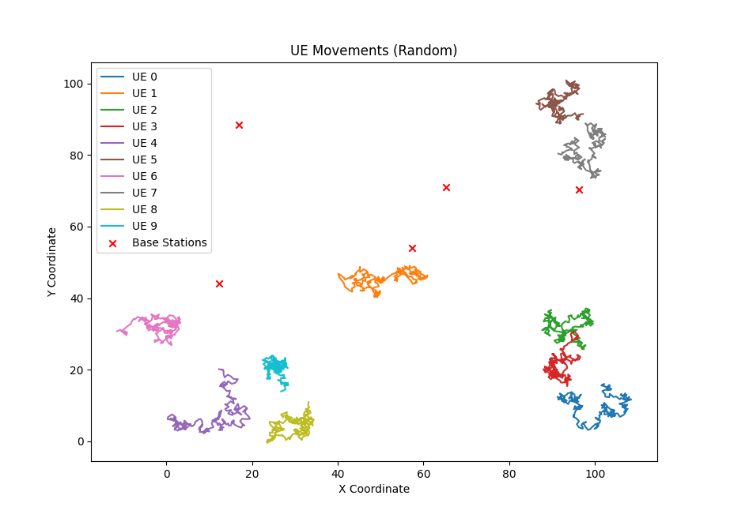

**Network Topology Visualization:**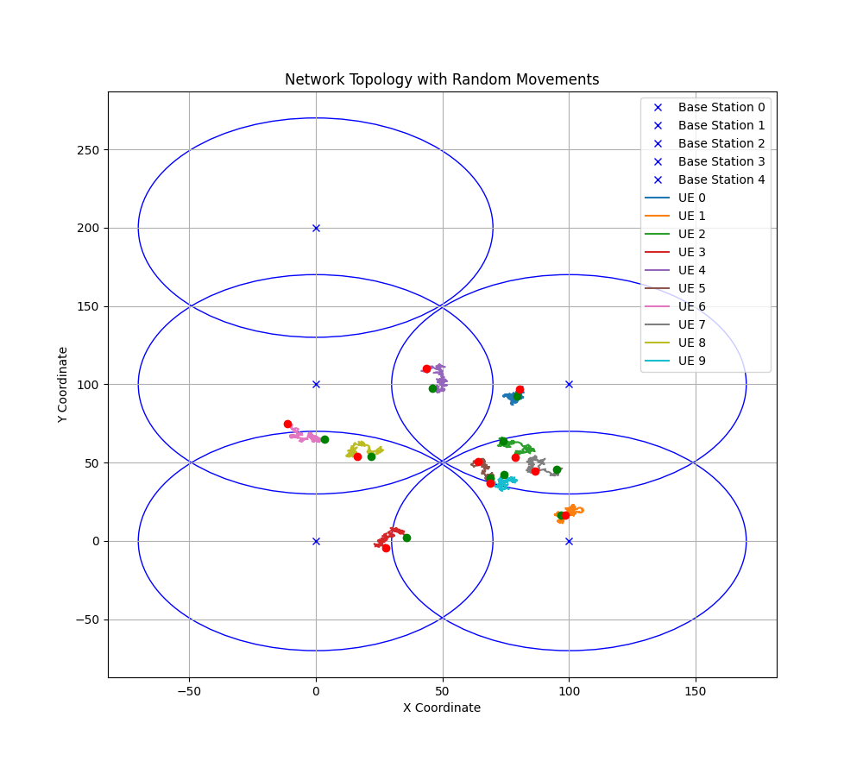

**6.2. Linear Movement (Threshold-Based Handover)**

* **Setup**: In this scenario, UEs move linearly through the network. A threshold-based handover algorithm is used, where UEs switch to a neighbouring base station when the signal strength drops below a certain threshold.
* **Results**:
  + **Total Handovers**: 56
  + **Average Handover Delay**: 6.361486400801594

Fewer handovers were observed, which resulted in greater network stability. However, the signal quality sometimes suffered as the UE held onto weaker connections longer.

**Graphs**:

* + **Handover Count Distribution**: Histogram of handovers performed by UEs.

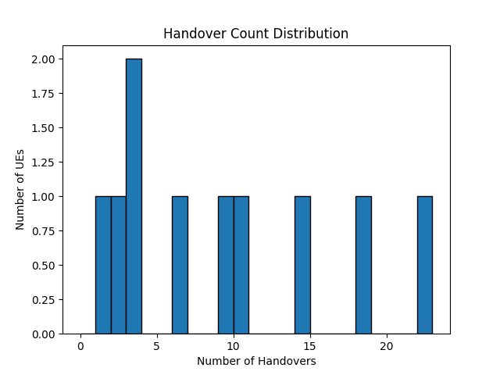

* + **Handover Delay Distribution**: Histogram of handover delays.

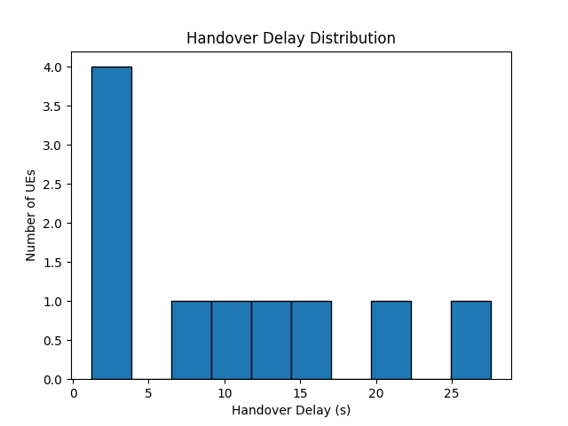

* + **UE Movement Visualization**: Linear paths of UEs and their interactions with base stations.

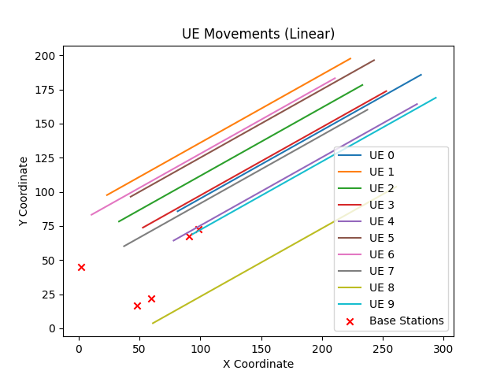

* **Network Topology Visualization:**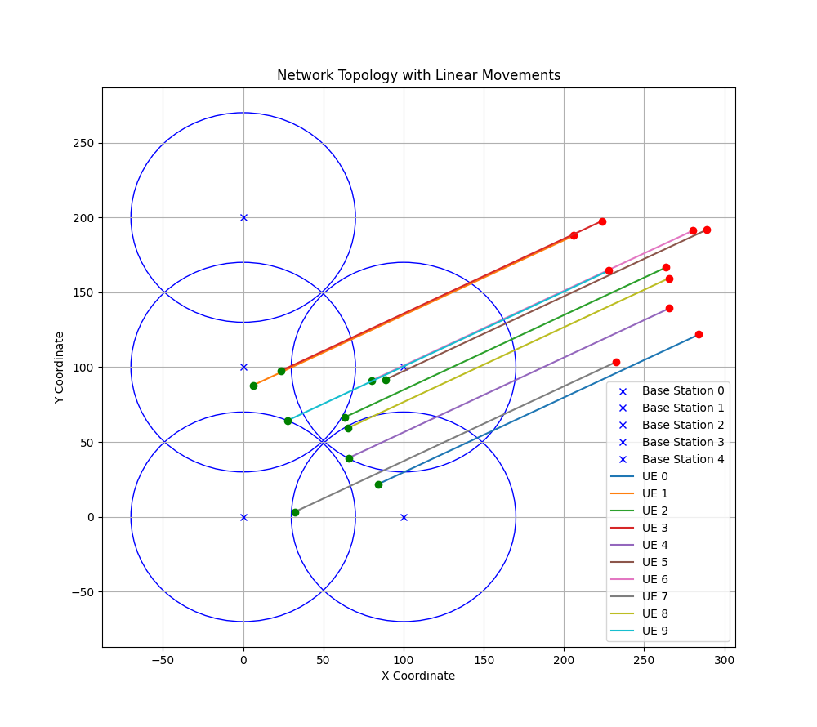

**6.3. Custom Paths (Cost-Based Handover)**

* **Setup**: In the custom path scenario, UEs follow predefined routes through the network. The cost-based handover algorithm optimizes handovers by considering base station load and signal strength.
* **Results**:
  + **Total Handovers**: 50
  + **Average Handover Delay**: 5.780005325070284

The results showed fewer handovers compared to RSSI-based and a more balanced load distribution among base stations. The cost penalty discouraged frequent handovers, which helped maintain network stability.

**Graphs**:

* + **Handover Count Distribution**: A histogram showing handovers across UEs.

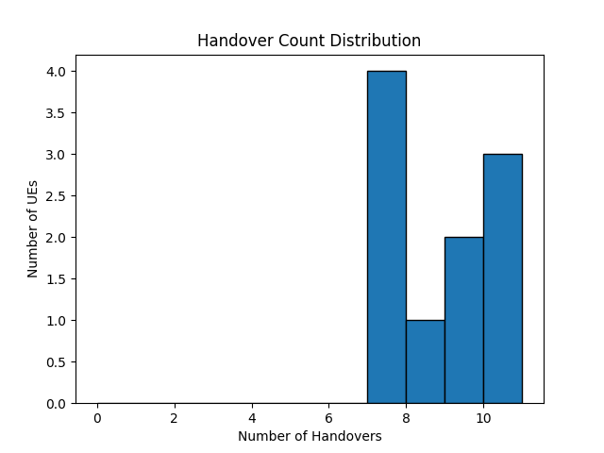

* + **Handover Delay Distribution**: Histogram of delays during handovers.

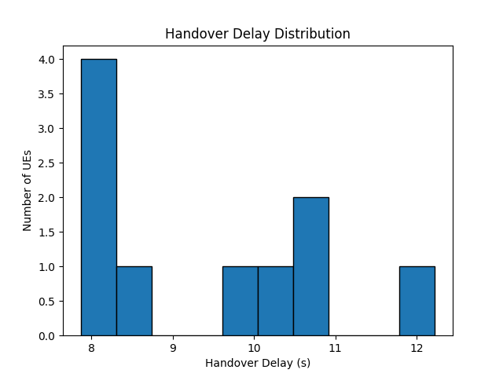

* + **UE Movement Visualization**: Visualization of custom paths and UEs’ handovers between base stations.

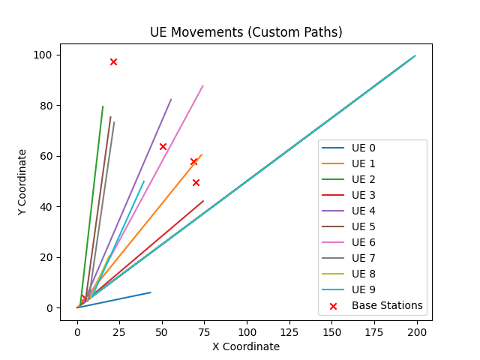

* **Network Topology Visualization:**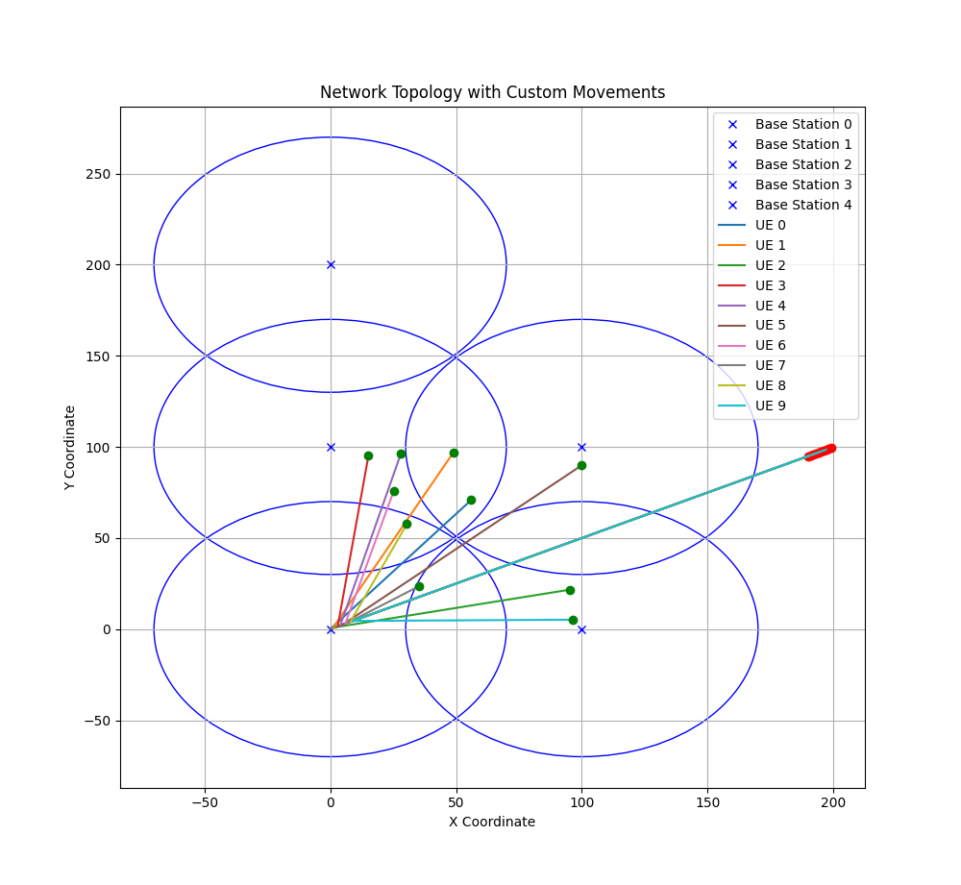

**Scenario Variation Analysis:**

To gain a better understanding of how each handover algorithm performs under different network conditions, various scenarios should be simulated, with changes in the number of UEs, base station density, and mobility patterns. This will allow for more comprehensive analysis and insights into the strengths and weaknesses of each algorithm in real-world scenarios.

* **Changes in the Number of UEs**
  + **Scenario Description**: We ran multiple simulations by varying the number of UEs from **5 to 100** while keeping the number of base stations constant. The goal was to assess how the handover performance of each algorithm scales with increasing network traffic.
  + **Impact on Handover Algorithms**:
    - **RSSI-Based Handover**: With an increasing number of UEs, the frequency of handovers increased significantly. Since each UE seeks the base station with the strongest signal, the network often became congested, especially in areas where multiple UEs overlapped in coverage. For example, with **50 UEs**, the number of handovers jumped from **30** to over **100** compared to simulations with only **5 UEs**, leading to instability and degraded network performance.
    - **Threshold-Based Handover**: Increasing the number of UEs led to fewer unnecessary handovers compared to the RSSI-based approach. The threshold prevented UEs from switching too frequently, maintaining more stable connections. However, there were instances where UEs experienced reduced signal quality for longer periods due to holding on to weaker connections.
    - **Cost-Based Handover**: The cost-based algorithm performed better under high UE density by balancing the load among base stations. With **100 UEs**, the handover count remained comparatively lower, around **70**, due to the consideration of both load and signal strength. However, handover delays were slightly longer due to the additional processing required for load balancing.
* **Changes in Base Station Density**
  + **Scenario Description**: The number of base stations was varied from **3 to 15** to evaluate how the handover performance changes with different levels of coverage and base station density.
  + **Impact on Handover Algorithms**:
    - **RSSI-Based Handover**: Increasing the number of base stations led to a sharp rise in handover frequency, especially with overlapping coverage. The number of handovers increased due to the UE constantly seeking the strongest signal in densely covered areas.
    - **Threshold-Based Handover**: Higher base station density improved network performance by reducing the likelihood of signal drops below the threshold. Fewer UEs experienced disconnections as there was always a nearby base station with adequate signal strength. The average handover count was reduced to **15-20** even in dense base station setups.
    - **Cost-Based Handover**: The increased base station density allowed for better load distribution, effectively reducing the number of handovers. The average number of handovers remained low (approximately **20-25**), with efficient use of base station resources. The penalty mechanism also ensured that UEs did not frequently switch between adjacent base stations with comparable signal strength.
* **Mobility Pattern Changes**
  + **Scenario Description**: We also analyzed the impact of different UE mobility patterns (random, linear, and custom paths) on the performance of the handover algorithms. Each mobility pattern represents a different type of real-world user behavior.
  + **Impact on Handover Algorithms**:
    - **Random Mobility**: This pattern represented unpredictable user movement. With random movement, handovers were highly frequent for the **RSSI-based algorithm** (e.g., **50-60 handovers per 200 steps**) due to constant fluctuations in signal strength. The **threshold-based algorithm** performed better under random movement, reducing the number of handovers to around **30** due to the threshold mechanism. The **cost-based algorithm** maintained stability by preventing handovers to overloaded base stations, achieving **20-25 handovers**.
    - **Linear Mobility**: Linear movement, such as that of a vehicle along a road, resulted in a more predictable handover pattern. The **RSSI-based algorithm** performed well in this scenario, with around **10-15 handovers**, as the gradual movement reduced the number of significant signal changes. The **threshold-based** and **cost-based algorithms** both showed similarly stable performance, with fewer handovers due to smoother transitions between base stations.
    - **Custom Paths**: The custom paths represented a mix of both random and predictable movement, simulating users in complex urban environments (e.g., pedestrians navigating through a city). **RSSI-based handovers** were more frequent in areas with frequent changes in direction. The **threshold-based algorithm** showed improved stability, while the **cost-based algorithm** maintained a balanced load across base stations. The number of handovers varied depending on the path's complexity, ranging from **15-35**.

**Conclusion on Scenario Variation**

By simulating these different scenarios, we observed how each algorithm adapted to changes in network conditions, such as increased UE density, changes in base station density, and different mobility patterns. Below is a summary of key observations:

* **RSSI-Based Handover** is highly sensitive to UE density and base station density, often leading to frequent handovers.
* **Threshold-Based Handover** reduces unnecessary handovers and is well-suited for high-density environments, but may result in reduced signal quality in some cases.
* **Cost-Based Handover** balances load and signal strength, making it a robust choice for maintaining stability across various scenarios, although it may result in slightly higher delays due to processing the cost calculations.

**7. Comparison of Handover Algorithms**

**7.1. RSSI vs Threshold vs Cost-Based**

* **RSSI-Based**: Tends to trigger frequent handovers as UEs always attempt to connect to the base station with the strongest signal. This may lead to network instability in areas with overlapping coverage.
* **Threshold-Based**: Reduces the number of handovers by avoiding switches until the signal strength drops below a critical level. However, it may lead to slightly degraded performance due to holding onto weaker signals.
* **Cost-Based**: Offers a balance between signal strength and load balancing. This approach results in fewer handovers compared to RSSI-based handover but performs better than threshold-based under high network load.

**8. Conclusion**

The results of this simulation demonstrate that each handover algorithm has distinct advantages depending on the mobility pattern and network conditions. RSSI-based handover offers high signal quality but may lead to frequent handovers, while threshold-based handover reduces handover frequency at the cost of potentially lower signal quality. The cost-based algorithm, while more complex, offers a balanced approach that optimizes both signal strength and network load.

For real-world applications, the appropriate handover strategy depends on the specific network environment. Urban areas with high base station density may benefit from cost-based handovers, while threshold-based handovers may be more appropriate for highway scenarios where frequent handovers are undesirable.